Capstone Project 5 – Brazilian E-Commerce Dataset
Data Source:
https://www.kaggle.com/datasets/olistbr/brazilian-ecommerce
About Dataset:
This is a Brazilian ecommerce public dataset of orders made at Olist Store. The dataset has information of 100k orders from 2016 to 2018 made at multiple marketplaces in Brazil. Its features allow viewing an order from multiple dimensions: from order status, price, payment and freight performance to customer location, product attributes and finally reviews written by customers. We also released a geolocation dataset that relates Brazilian zip codes to lat/lng coordinates.
This is real commercial data, it has been anonymised, and references to the companies and partners in the review text have been replaced with the names of Game of Thrones great houses.
Context
This dataset was generously provided by Olist, the largest department store in Brazilian marketplaces. Olist connects small businesses from all over Brazil to channels without hassle and with a single contract. Those merchants can sell their products through the Olist Store and ship them directly to the customers using Olist logistics partners. See more on website: www.olist.com
After a customer purchases the product from Olist Store a seller gets notified to fulfil that order. Once the customer receives the product, or the estimated delivery date is due, the customer gets a satisfaction survey by email where he can give a note for the purchase experience and write down some comments.
Attention
- An order might have multiple items.
- Each item might be fulfilled by a distinct seller.
- All text identifying stores and partners were replaced by the names of Game of Thrones great houses.

Data Schema
The data is divided in multiple datasets for better understanding and organization. Please refer to the following data schema when working with it:
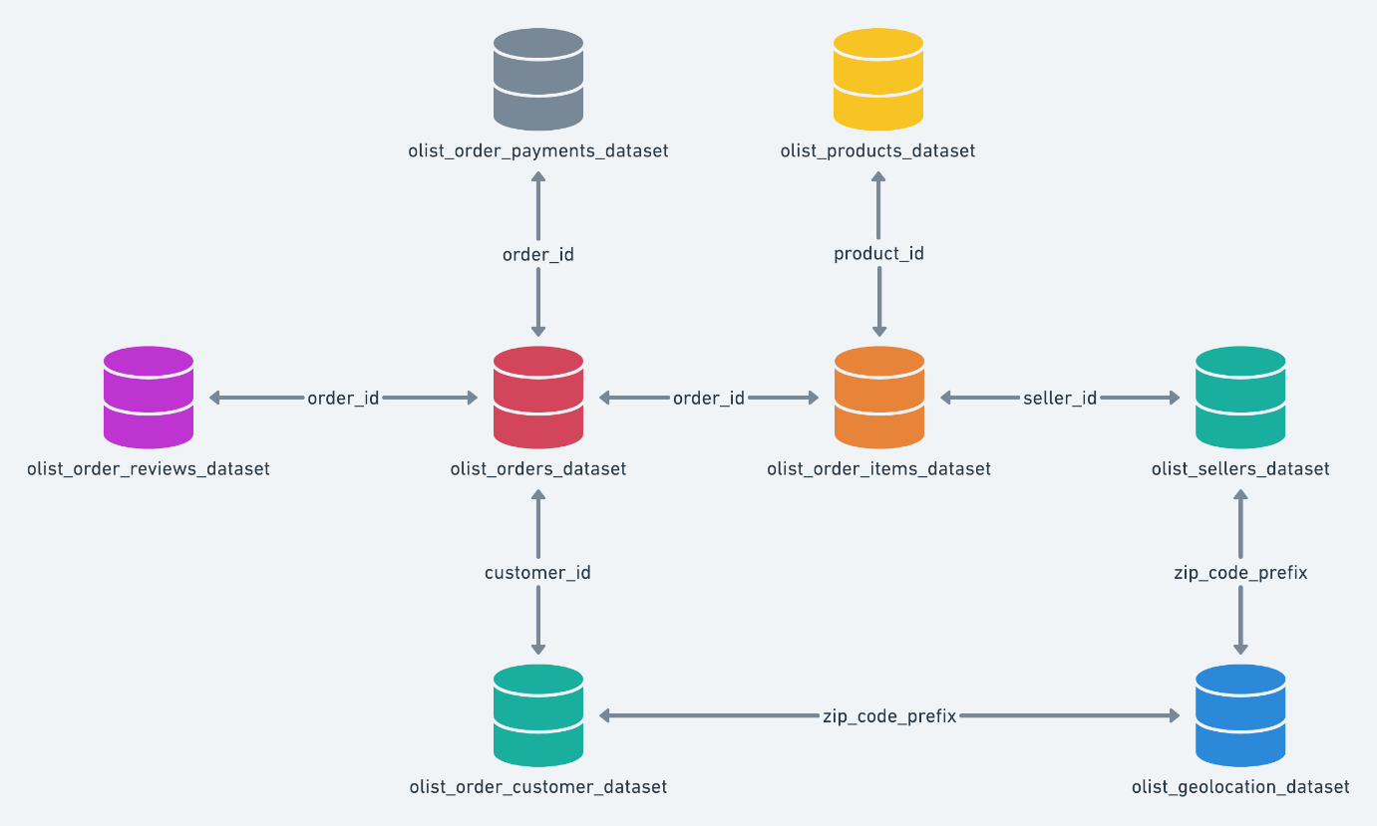
Objective:
Perform exploratory analysis and come up with various insights from the dataset which include KPIs, Purchase trends, Customer demographics, Order patterns, Product reviews, Payment methods, Seller sales and Overall sales patterns etc.
Analysis Ideas:
- What is the average transaction value?
- Most bought customer categories
- Trend of sales over the day, week and month
- Number of products bought by each customer

